Puppies sometimes available,
From quality healthy stock. Also carefully selected breeding stock, while breeding to our standard to produce best possible quality. C H -Top Stud dogs. / Known for their consistency in Performance, quality and Progeny: Available for approved Bitches only.
AVAILABLE: YES → Yorkshire Terriers puppies (2.) females and (2.) males available.
We would like to advice you that if you want to get quick and fast information do please contact the breeder directly by phone! Mobile: Ph: 0406043137





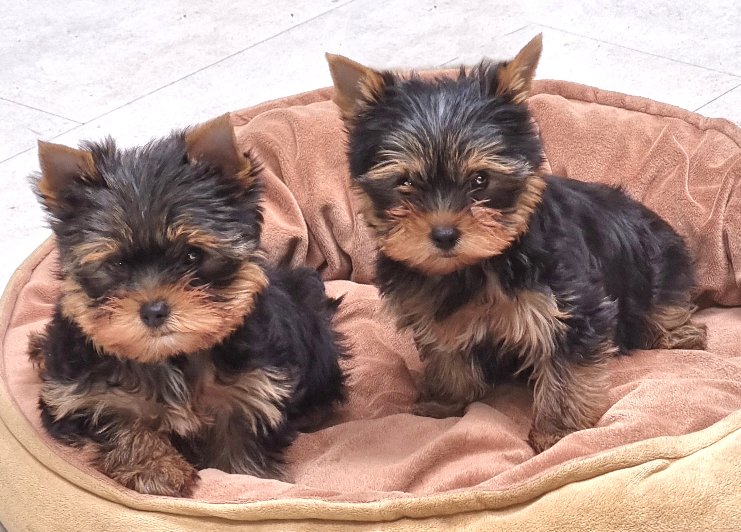
Two Ausilk Yorkshire Terrier puppies

